BASH -02

1.Create a bash script to check if a directory is available or not.
First we need to edit the file using vi and that file should be executed with proper file permissions using chmod and at last we should execute ./filename.sh.
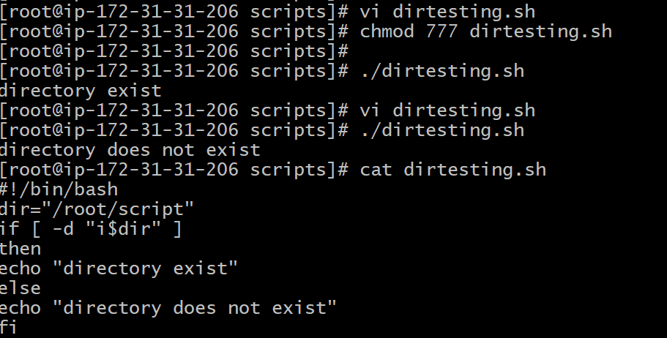
2.Create a bash script to create multiple files.
We use for loop to create multiple files.
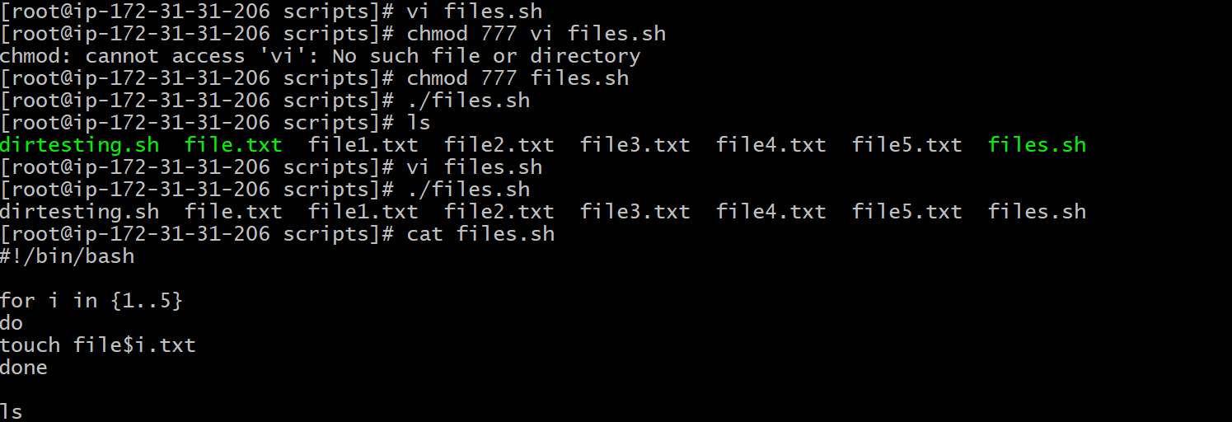
3.Create a bash script to take a backup of a directory.
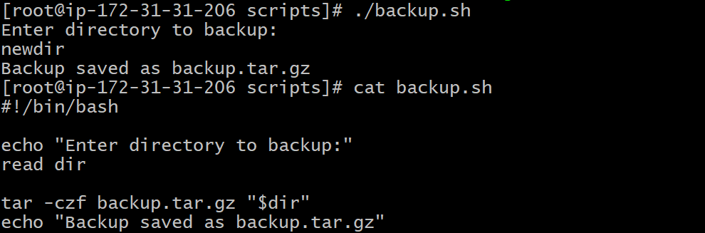
4.Create a bash script to install Nginx on an ec2 server.
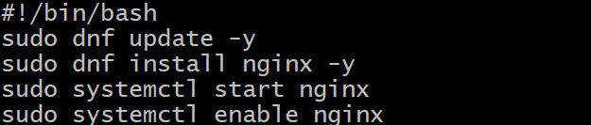
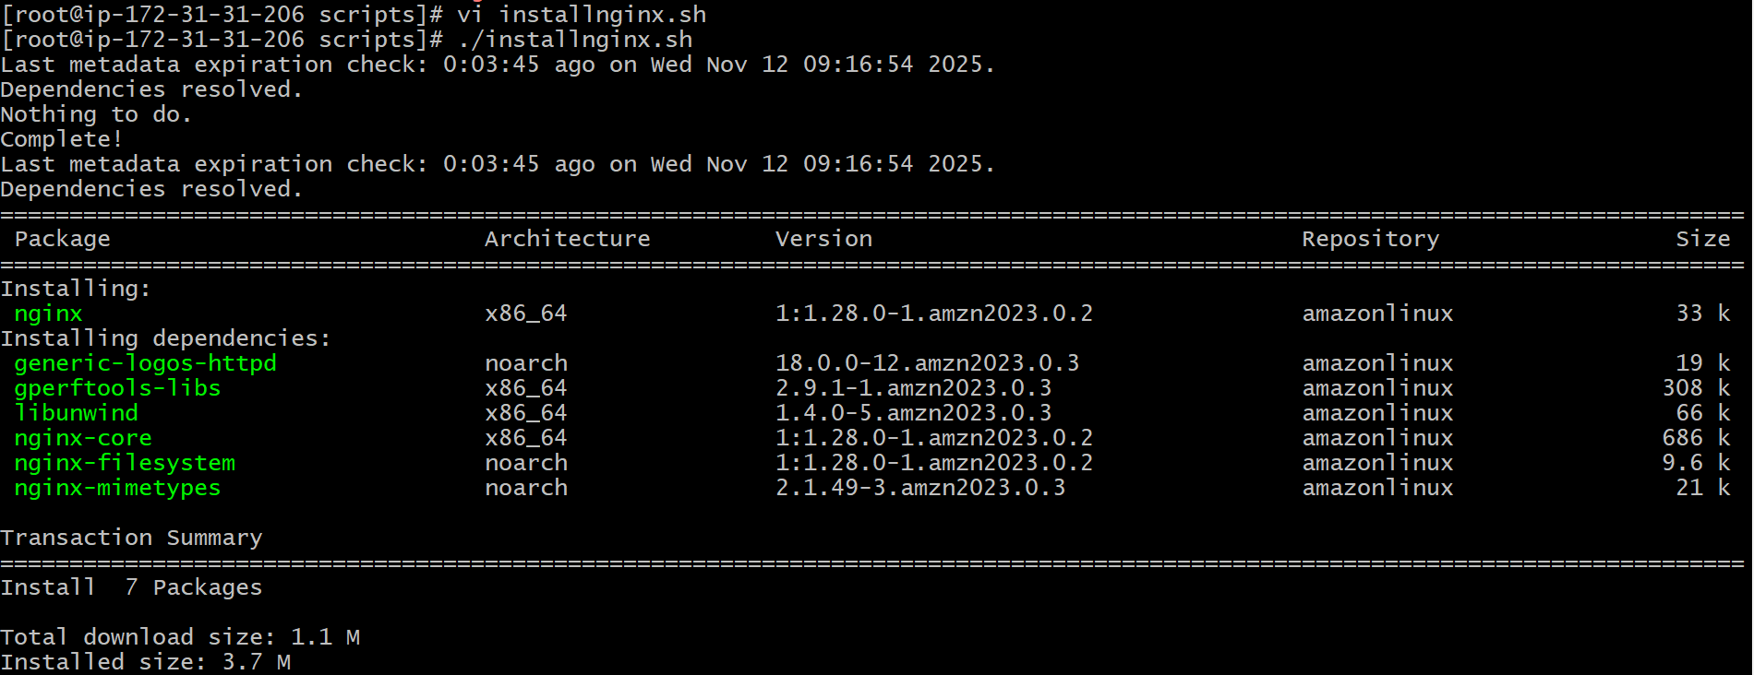
5.Create a bash script to install Apache Tomcat on an ec2 server.
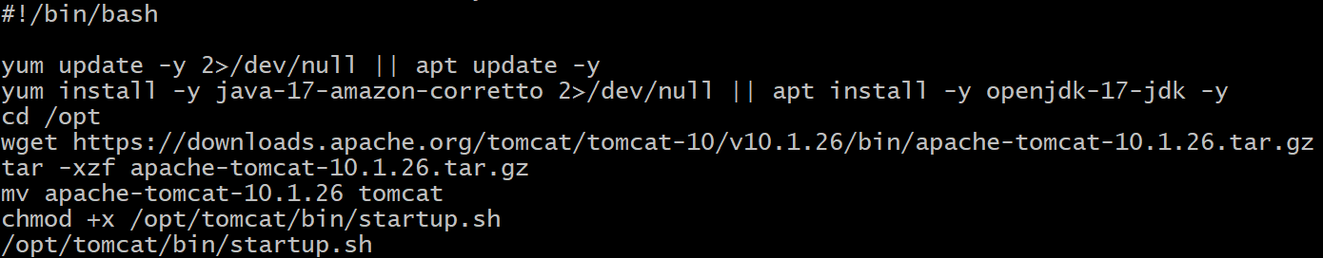
First we need to install java which is required for tomcat.
Go to /opt directory,
Download Tomcat from internet.
Extract the downloaded file.
Rename the directory that is from apache-tomcat-10.1.26 to tomcat.
Permissions to be provided.
/opt/tomcat/bin/startup.sh.
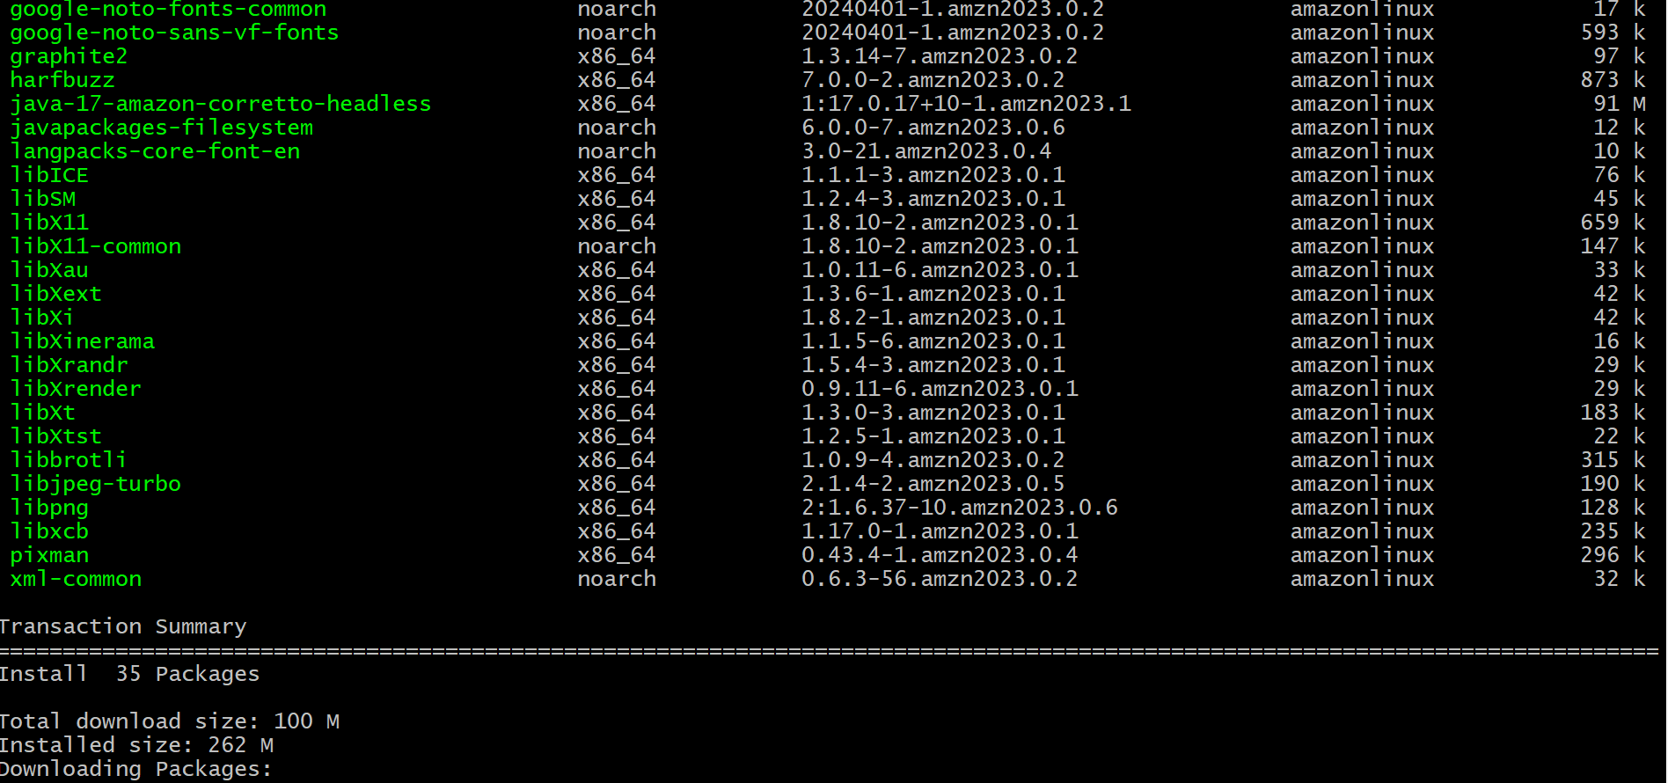
6.Create a bash script to check if the Nginx service is running, if not running then script should start the service.
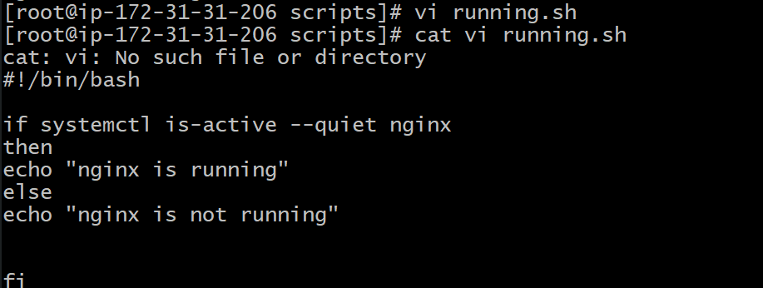

7.Create a bash script for a calculator.
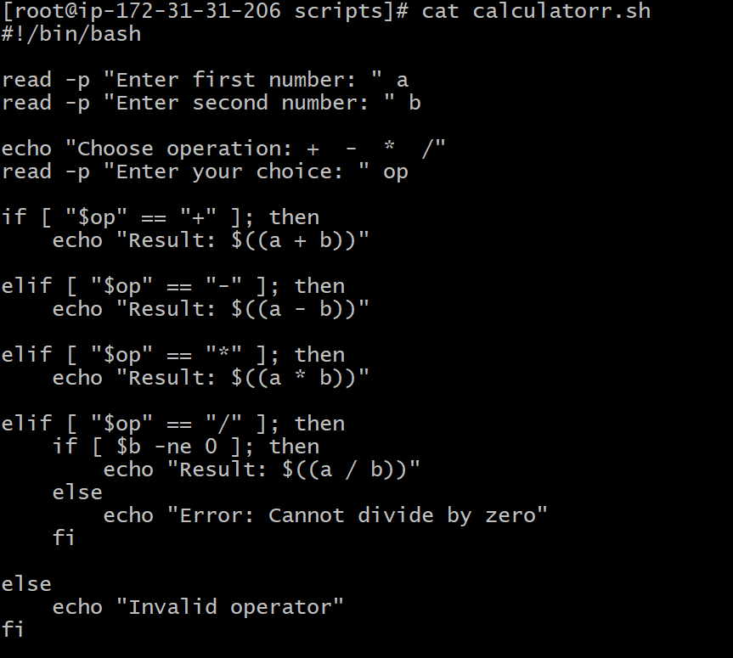
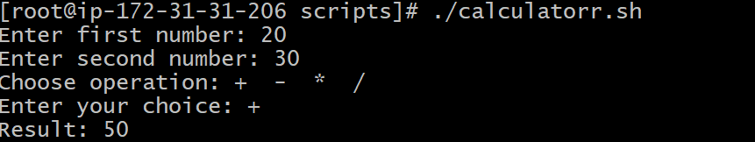
8.Create a bash script to check if a directory exists, if not then create a directory.
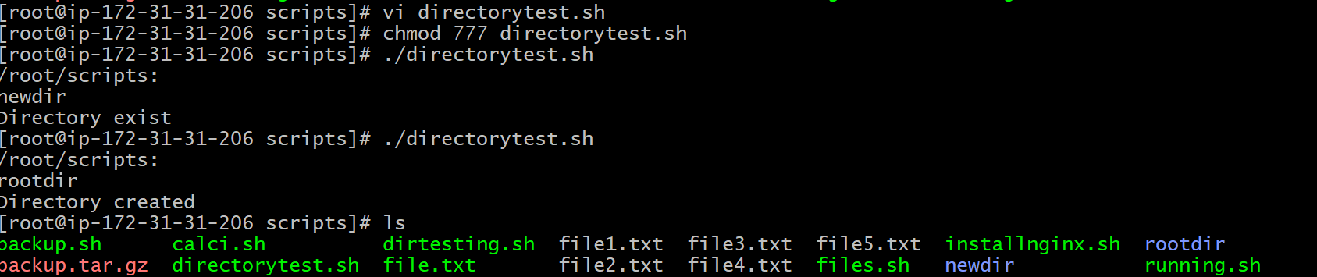
9.Create a bash script to delete the last 3 lines of a file.
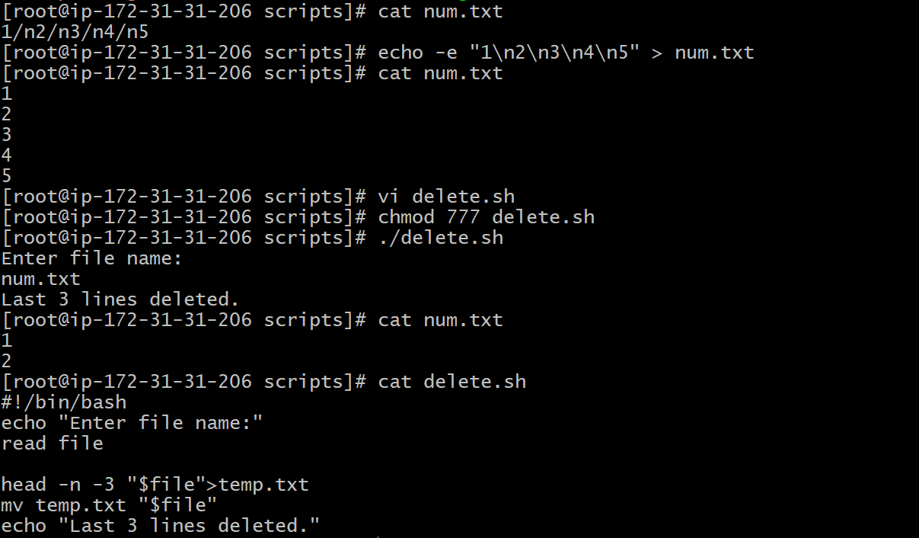
10.Bash script to monitor cpu and if it is more than 80% then send email notification.
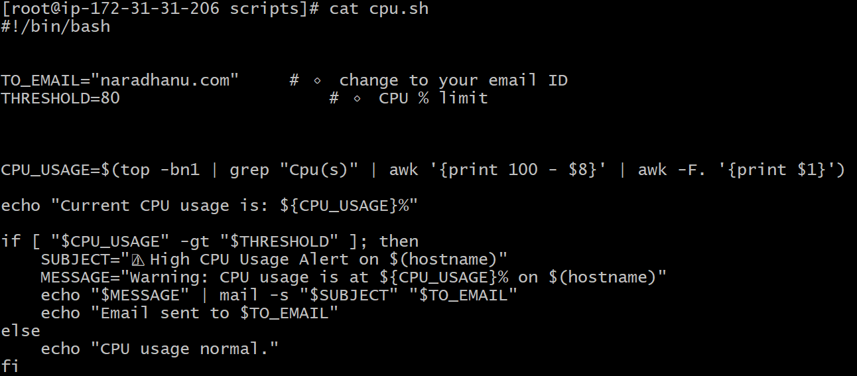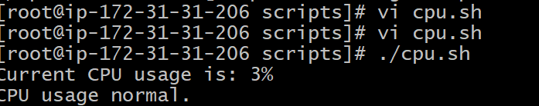
11.Bash script to monitor disk space and if it is more than 80% then send email notification.
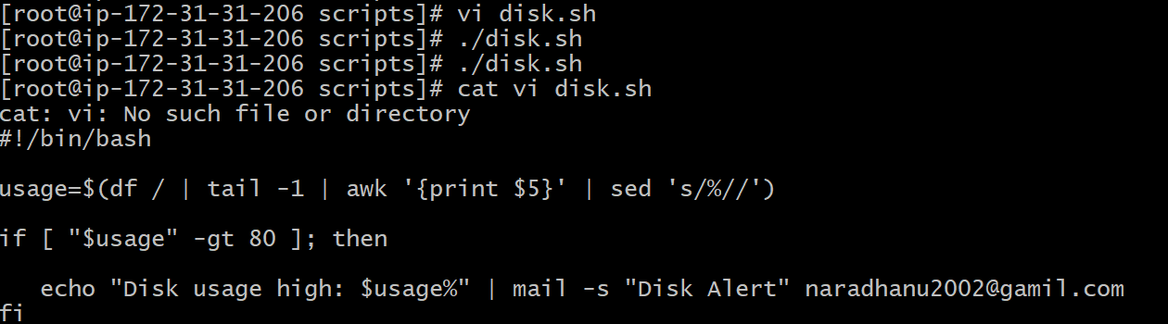
12.Bash script to monitor memory and if it is more than 80% then send email notification.
